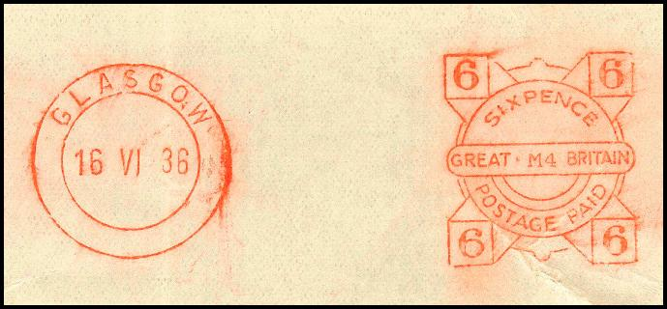

Editor: Alastair Nixon, 7 Bramblegate, Edgcumbe Park, Crowthorne, Berks, RG45 6JA. Tel: +44 (0) 1344 775378

Email: alastair@nixon48.freeserve.co.uk Web site: http://www.meterfranking.co.uk

.

Meter of the Month

Some very exciting news this month for those who are interested in the early Great Britain ‘Design A’ franks, thanks to Jim Ashby. Jim has discovered a previously unreported variation on a Midget frank.

In order to set the scene, the item below shows the well-recorded variations of the value die, one with a single arc and one with no arc. The second item shows the much rarer ‘double-arc’ variety.

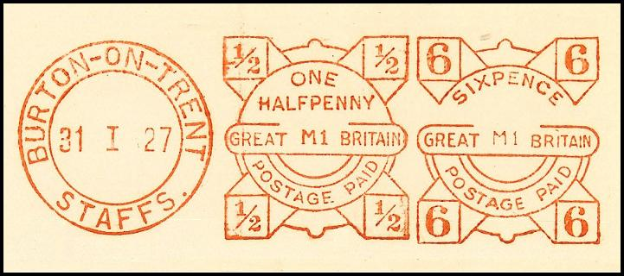
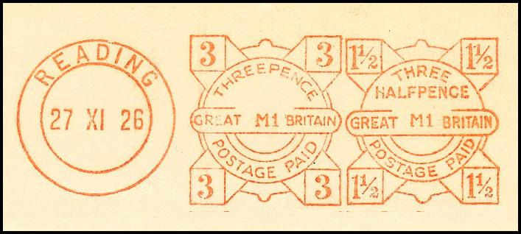

Now Jim has found a further variation, this time with a double-arc and an unbroken frame line above ‘Great Britain’ as shown below:

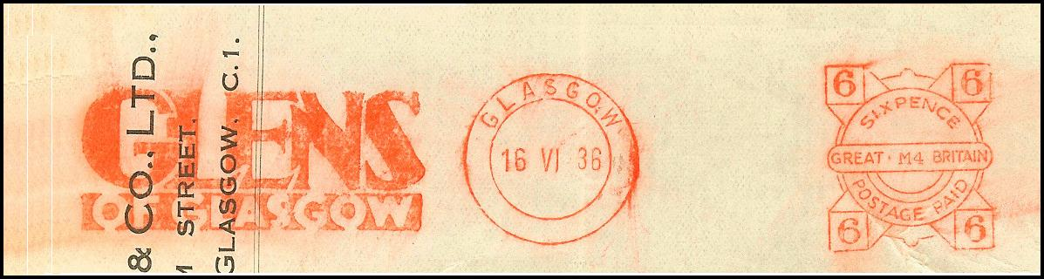

Again, my thanks to Jim for reporting this new discovery.

Acknowledgements

My thanks this month go to Jim Ashby, David Aspinwall, David Crotty, Alan Godfrey, Richard Goring, Ross Irwin, David Jones, Peter Mantell, Stafford May, Richard Peck, Ed Shales, Peter Wood and Ray Woodward-Clarke for their reports and communications.

Latest Numbers
Below is the list of ‘Latest Numbers’ as at 28th February 2010 – with updates shown in red. Please could I have the next reports by 26th March, thanks.

Frama (UK)

Matrix F2 F1000298 20.01.10 Reported by RG

EcoMail FSC356030 06.11.09 See MN 109

MailMax FSC909446 04.09.09 See MN 107

Francotyp-Postalia

Optimail? B 0788095 23.03.09 See MN 101

Optimail T402872 12.10.09 See MN 108

Optimail 30 F04111990 03.11.09 See MN 109

Centormail FC5110374 27.11.09 See MN 110

Mymail FM2119781 18.12.09 Reported by RG

Ultimail? FU3115313 24.02.10 Reported by PM

Neopost

IS-330 N1050606 25.02.09 Reported by AN

IS-350 (Ex IJ-25) N1172624 08.02.10 Reported by AN

IJ-65 N1208315 30.10.09 See MN 109

Various upgraded N1240468 05.11.09 See MN 109

IJ-80/90/110 N1254094 21.12.09 See MN 111

Various upgraded N1290060 22.12.09 Reported by RG

IJ-35/45 N1317911 12.10.09 See MN 109

IS-460 (Ex IJ-50) N1373322 03.03.09 See MN 101

IS-420 (Ex IJ-30) N1385071 15.01.10 See MN 111

IS-440 (Ex IJ-40) N1390234 20.01.10 See MN 111

IS-480 N3010564 23.02.10 Reported by AN

Pitney Bowes

DM50, 55 PB053180 04.02.10 Reported by AG

DP200? PB130194 01.12.09 See MN 110

DP400? PB143208 08.06.09 See MN 106

DP400? PB148004 03.04.09 See MN 105

Personal Post PB294355 21.12.09 See MN 110

DM 200? PB311641 15.01.09 See MN 107

Personal Post PB499249 18.08.09 See MN 109

DM 550 etc. PB526258 25.01.10 See MN 111

DM 400C / 450C PB613967 29.01.10 See MN 111

Post Perfect PB764266 14.01.10 See MN 111

DM100i PB847149 26.02.10 Reported by AN

Advanced Mail

AABJ-LC N1253924 07.07.09 See MN 106

.

Recent Interesting Items

Peter Mantell reports a new font size appearing in the value die of new DM100i (PB8 series) machines. Peter provides an example of the new value die with PB844730, below. Also below, your editor illustrates an example of the old font size for comparison purposes.
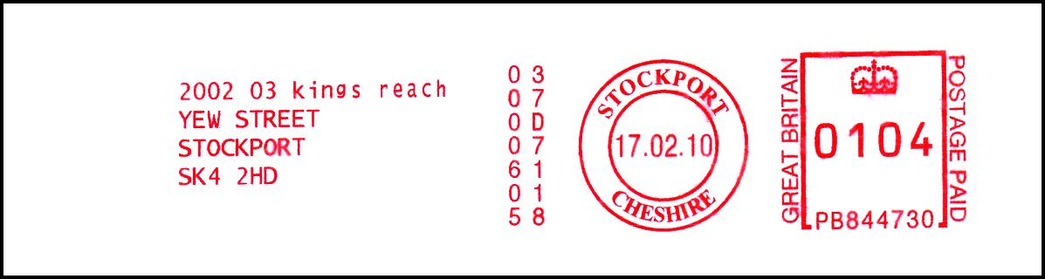

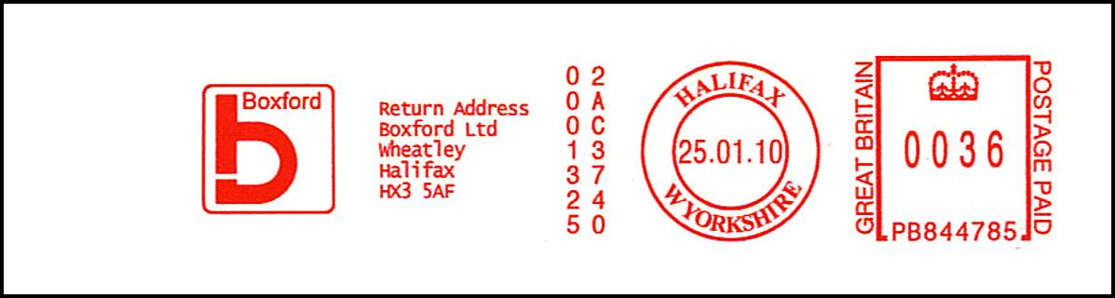

The hunt is now on to find the changeover point in the series, but the situation so far appears to be a little complicated with an overlap - as the following table shows:

Serial | Date | Comment
PB844691 | 07.01.10 | All below this number (including this one) are in the small format
PB844730 | 17.02.10 | Lowest number in the large format (see above)
PB844785 | 25.01.10 | Highest number in the small format (see above)
PB844875 | 22.02.10 | All above this number (including this one) are in the large format.
PB845045 | 22.01.10 | Earliest date seen in the large format.

Any updates to the above table (with scanned images please) would be welcome. Until the picture is clearer, your editor would appreciate reports of all franks in the range PB844600 to PB844999. To complicate matters further, it appears that some of the older machines are now being converted to the large value types as shown in the example below. This modification is probably carried out by a software change by the manufacturer when a machine is re-furbished or by a field service engineer. Reports of converted older machines are not required.
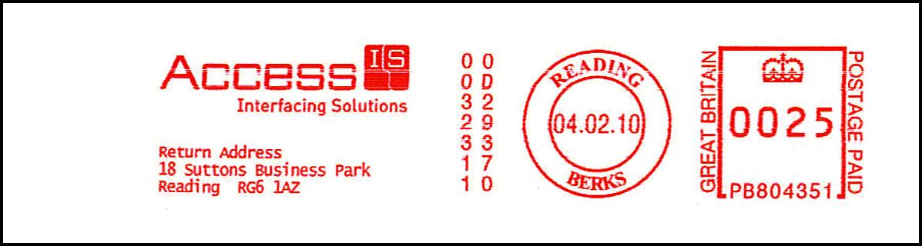

Recent Interesting Items continued

Peter Mantell reports what looks like a change of ownership for this Francotyp-Postalia machine (F04111373). In January 2009, it was being used in London SE (unfortunately the user at that time is unknown), but a year later it appears in Bury St. Edmunds, Suffolk. As has been stated on previous occasions, changes of ownership are probably fairly common, but finding them is hard. Note also that the town name in the illustration has lost the ‘BURY and it just shows ‘ST EDMUNDS’. This is surely an error as, according to Wikipedia, the local residents often simply refer to the town as ‘Bury’. [The word ‘Bury’ has etymological connections with ‘borough’ and hence it does not mean that St. Edmund was buried there.]


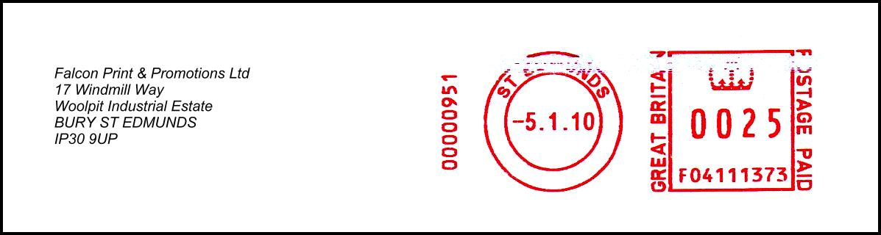

5-element franks are uncommon on PB6 series franks, but Peter Mantell has found this example. Note that the return address appears twice!
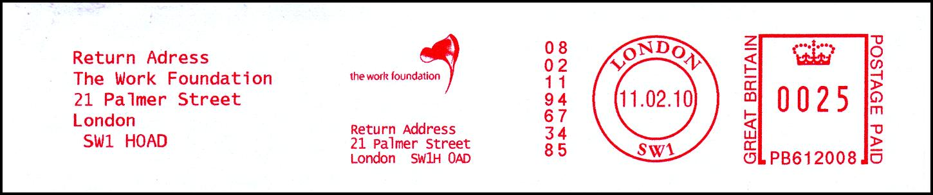

Peter sends this FC5 series frank with a ‘FIRST CLASS’ endorsement and asks whether this counts as a 5 or 6 element frank. Certainly it is longer than the one shown on page 99-7.
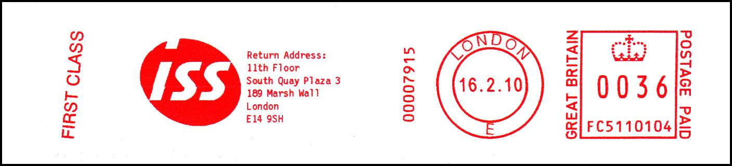

Meter Correction Machine Cancels from the 1980s and 1990s – Part 2

Further to page 111-11, we continue the story of the meter correction marks of the 1980s and 1990s, supplied by Ray Woodward-Clarke.

‘WATFORD METER POST POSTED ON DATE SHOWN NOT AS METER POSTMARK’ was used at Watford M.L.O. – see example below..


Similar dies were used at Sheffield and Belfast and also for Cheshire Meter Post - see examples below. All these have been seen in both black and red.
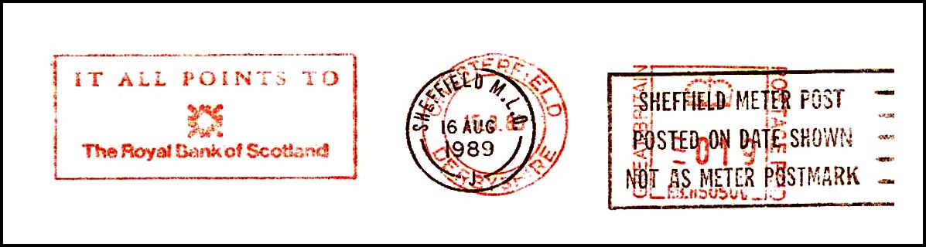

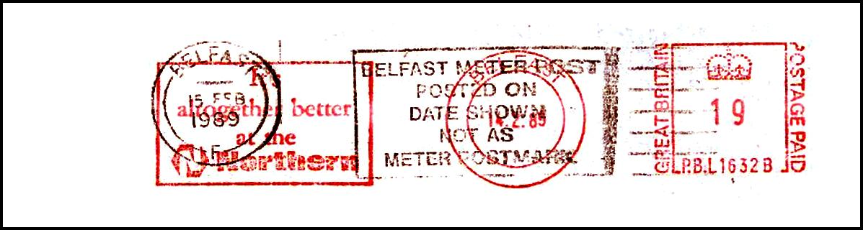

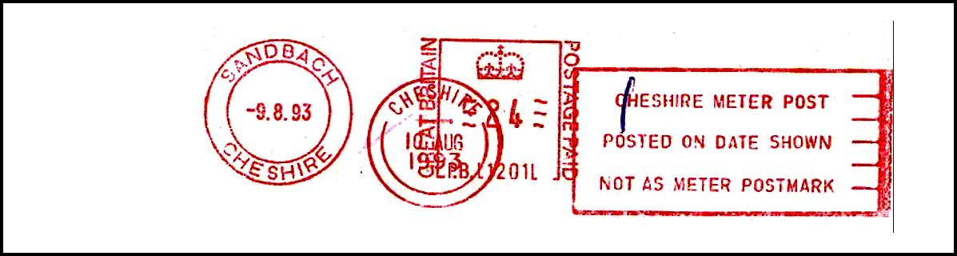

Your editor hopes to continue the story next month.

Interesting Items from the Past

Dave Baker provides three interesting items from the past. The first is this one, made by a model CV machine in 1965 and which bears a ‘LETTER POST’ slogan.



Dave also supplies this Pitney Bowes frank - made by a Model 5333 machine exactly eight months after the very first appearance of the Design H (decimal) frank on 12th June 1968.
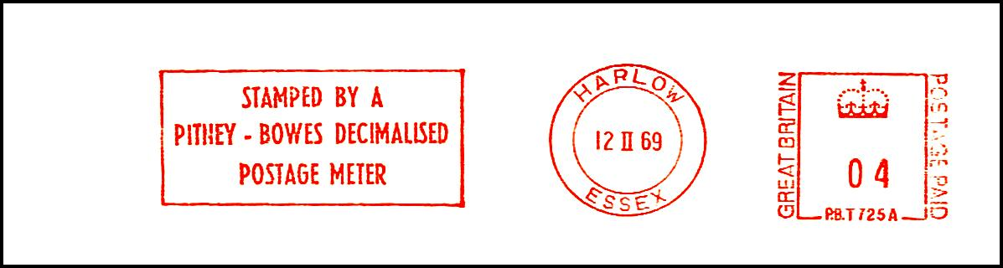

Dave also sends this Pitney Bowes specimen frank, made by a Simplex machine PBS180W in1985. This franking machine was available for inspection at a Postal Mechanisation exhibition, held at the National Postal Museum that year. An example frank, similar to the one below, was given to every visitor to the exhibition.
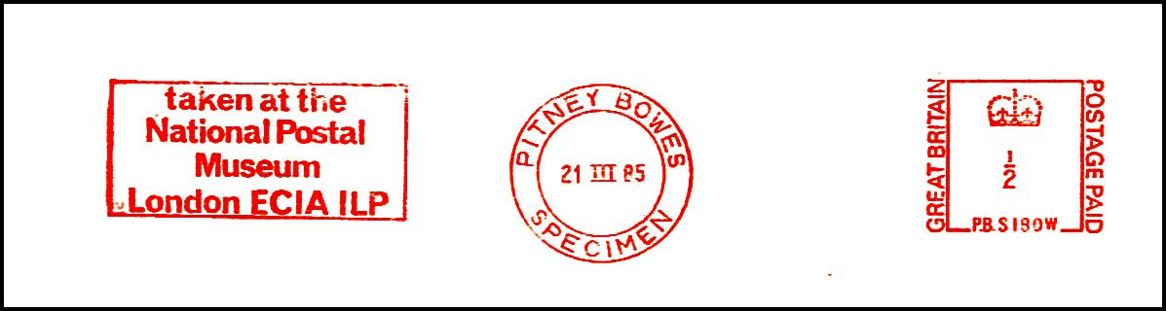

Peter Mantell sends an example of an inverted town die - from a Neopost Model 205. These inverted dies are rarely seen and reports of other examples would be appreciated.


Meter Thematics from the Past

Peter Mantell has found an unusual thematic slogan from 1976 showing a snail:



Meanwhile, your editor has found this attractive ladybird from 1992:



Dave Baker has kindly supplied two interesting Pop Singer thematics from 1985, advertising their new albums. The same Hasler F204 machine (serial HF94680) produced them both. The first advertises Mick Jagger’s solo album ‘She’s The Boss’:
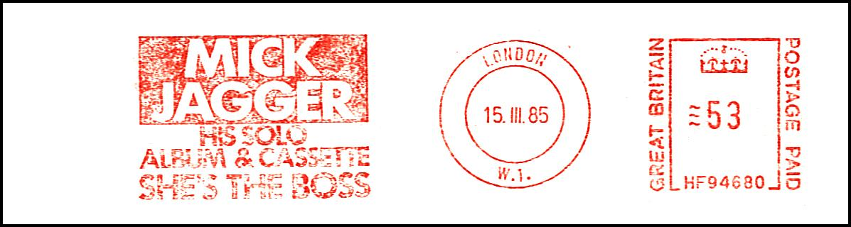

The second advertises Carly Simon’s album ‘Spoiled Girl’:
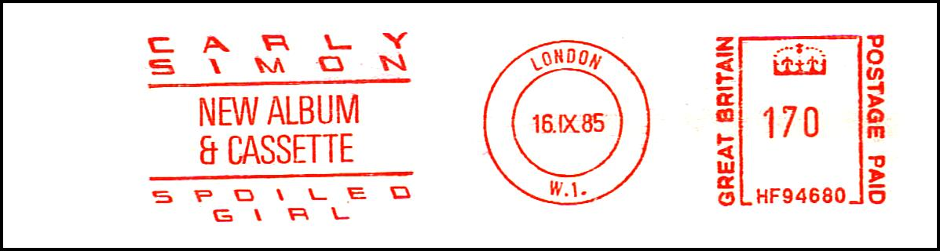

Meter Thematics

Richard Goring sends this palm tree design from a company called Haulfryn, which markets holiday and residential homes, including static caravans, targeted at the South of England and the West Country.
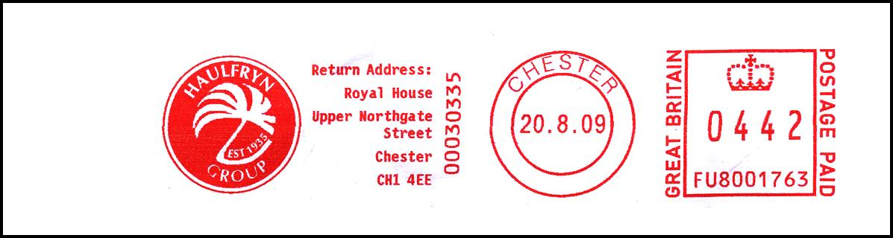

David Jones sends this attractive slogan depicting the Gloucester City skyline – including the cathedral:


Peter Mantell has found this elephant which is rather fun.


Peter also sends this cute terrier dog from TCN Property Management Ltd. and is a worthy winner of my Meter Thematic of the Month award.



