

Editor: Alastair Nixon, 7 Bramblegate, Edgcumbe Park, Crowthorne, Berks, RG45 6JA. Tel: +44 (0) 1344 775378

Email: alastair@nixon48.freeserve.co.uk Web site: http://www.meterfranking.co.uk

.

Meter of the Month

It is unusual for an overseas frank to make it as my Meter of the Month, but I could not resist this one from Malaysia. The 2009 Chinese New Year was celebrated on 26th January 2009 and we are now in the Year of the Ox. The complete image is shown below:

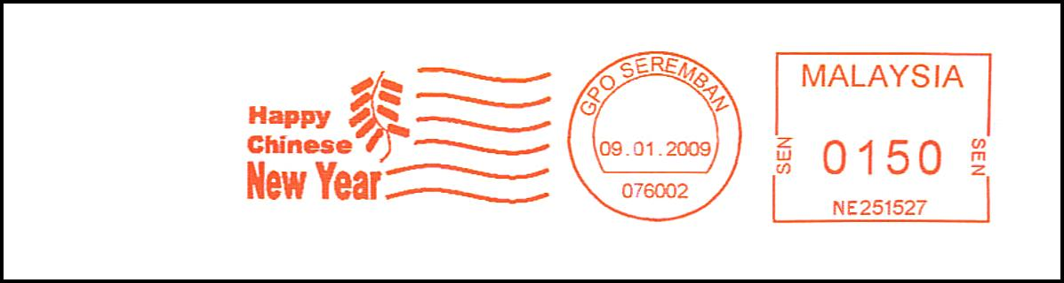

New Frama Machines

In his monthly trawl of the manufacturer web sites, Richard Goring has found that Frama are now marketing three new machines, namely the Matrix F2, the Matrix F4 and the Matrix F6. The Ecomail and Officemail are no longer advertised but the Mailmax II is still there. It is not known whether the old machines are still used as the basis for the new Matrix machines. It is not clear at this stage whether the FSC3 series will continue or be replaced to reflect these new machines. Until the position has been clarified, I shall continue to identify the existing FSC3 series on the highest numbers page as the Ecomail. Further details on these new machines are given on page 99-5.

Editorial

This month I have analysed the volumes of new machines sold during in the UK over the past year - see pages 99-4 & 99-5. This time, however, I have decided to split the analysis into three parts – Low, Mid and High volume machines, with some interesting results!

Membership & Acknowledgements

This month I would like to extend a warm welcome Merv Dadswell as member number 0027. Merv is new to the hobby but has kindly supplied some useful lists of his findings.

My thanks this month go to Jim Ashby, Merv Dadswell, Alan Godfrey, Richard Goring, Peter Mantell, Richard Peck, and Peter Wood for their reports and communications.

Latest Numbers
Below is the list of ‘Latest Numbers’ as at 30th January 2009 – with updates shown in red. Please could I have next month’s reports by 26th February, thanks.

Frama (UK)

EcoMail FSC353199 25.11.08 See MN 98

MailMax FSC909183 09.01.09 Reported by PM

Francotyp-Postalia

Optimail? B 0770780 01.02.08 See MN 90

Optimail T402747 14.01.09 Reported by AN

Optimail 30 F04111373 14.01.09 Reported by PM

Centormail FC5110287 22.01.09 Reported by RG

Mymail FM2119441 26.11.08 Reported by RG

Mymail FM2210997 14.11.08 See MN 98

Ultimail? FU3114528 12.01.09 Reported by AN

Ultimail 65 FU8002494 10.09.08 See MN 97

Ultimail 95 FU9001148 06.02.08 See MN 91

Neopost

IS-350 (Ex IJ-25) N1167727 19.11.08 Reported by RG

IJ-65 N1208304 20.01.09 Reported by PM

IS-480 (Ex IJ-85) N1240366 27.01.09 Reported by PM

IJ-80/90/110 N1253771 09.01.09 Reported by PM

IJ-85 N1290017 23.01.08 See MN 90

IJ-35/45 N1317747 20.11.08 See MN 97

IS-430 (Ex IJ-40) N1359997 07.08.08 See MN 95

IS-460 (Ex IJ-50) N1373277 27.01.09 Reported by PM

IS-420 (Ex IJ-30) N1384631 11.09.08 See MN 95

IJ-40 N1390062 16.10.08 See MN 96

Unknown N3004215 21.01.09 Reported by PM

Pitney Bowes

Paragon PBP84118 19.03.08 See MN 92

DM50, 55 PB038334 13.11.08 Reported by RG

DP200? PB130122 24.09.08 See MN 95

DP400? PB143184 18.07.08 See MN 93

Personal Post PB279196 28.07.08 See MN 94

DM 200? PB311616 01.08.08 See MN 94

DM 225, 300 PB380543 23.07.08 See MN 94

Personal Post PB493255 20.01.09 Reported by PM

DM 550 etc. PB524977 17.12.08 Reported by PM

DM 400C / 450C PB612762 16.01.09 Reported by PM

Post Perfect PB763934 20.10.08 See MN 98

DM100i PB839795 15.01.09 Reported by AN

My thanks also go to Merv Dadswell for his reports.

Franking Machine Specification Summary

In order to prepare for a more detailed analysis of UK franking machine sales in 2008, I have decided to allocate the currently available machines into three categories – Low, Mid and High speed. The machines falling into each category are grouped according to the throughput (speed) advertised on the manufacturer web sites, as defined below:

Category A Small User / Low Volume (less than 60 ipm)
Manufacturer | Machine | Speed | Serial Prefix
Frama | Ecomail | 33 ipm | FSC3
Francotyp-Postalia | Mymail | Unspecified | FM
Francotyp-Postalia | Optimail | 25 ipm | T40
Francotyp-Postalia | Optimail 30 | 25 ipm | F0
Neopost | IJ-25 AutoStamp | 20 ipm | N11
Neopost | IJ-25e & IJ-25ePro | 20 ipm | N3?
Neopost | IS-350 | 40 ipm | N11
Pitney Bowes | Personal Post | 20 ipd | PB2, PB4
Pitney Bowes | DM 50 / 55 | 30 ipd | PB0
Pitney Bowes | DM100i / DM150i | 30-40 ipm | PB8
Pitney Bowes | DM200i | 40 ipm | PB31?

Category B Mid Volume (60 to170 ipm)
Manufacturer | Machine | Speed | Serial Prefix
Frama | Mailmax II | 165 ipm | FSC9
Francotyp-Postalia | Ultimail 65 | 65 ipm | FU3, FU8
Francotyp-Postalia | Ultimail 95 | 95 ipm | FU3, FU9
Francotyp-Postalia | Centormail 240 / 300 | 120-150 ipm | FC
Neopost | IJ35/45 | 60-90 ipm | N131
Neopost | IS-420 | 65 ipm | N138
Neopost | IS-430 | 95 ipm | N135, N139
Neopost | IS-460 | 110 ipm | N137
Neopost | IS-480 | 150 ipm | N124
Pitney Bowes | DP200 / 400 | Unknown | PB13, PB14
Pitney Bowes | DM300c | 65 ipm | PB38
Pitney Bowes | DM400c | 95 ipm | PB6
Pitney Bowes | DM450c | 120 ipm | PB6
Pitney Bowes | DM550 / 575 | 160 ipm | PB1?

Category C High Volume (greater than 170 ipm)
Manufacturer | Machine | Speed | Serial Prefix
Neopost | IJ-65 | 180 ipm | N120
Neopost | IJ-80e | 180 ipm | N125, N129
Neopost | IJ-90e | 215 ipm | N125, N129
Neopost | IJ-110e | 250 ipm | N125, N129
Pitney Bowes | DM800i / 900i | 210-240 ipm | PB5
Pitney Bowes | DM990i / 1000i | 260 ipm | PB5

Statistics – 2008
Further to page 99-1, here is my analysis of sales of new machines in 2008 in the UK. The estimates exclude overseas block allocations. The new series that appeared in 2008 are indicated by asterisk marks and the Dec 2007 column has the start number in brackets. Single ‘one-off’ numbers have been omitted from the analysis.

Frama Dec 2008 Dec 2007 Difference Estimate (UK)

Low EcoMail FSC353199 347913 5286 1322

Mid MailMax II FSC909003 907863 1140 285

Francotyp-Postalia

Low Optimail T402677 402267 410 410

Low Optimail 30 F04111334 4110842 492 492

Mid Centormail FC5110256 5110151 105 105

Low MyMail FM2119441 2116586 2855 2855

Mid Ultimail * FU3114448 (3113670) 778 778

Mid Ultimail 60/65 FU8002494 8002404 90 90

Mid Ultimail 90/95 FU9001148 9001133 15 15

Neopost

Low IJ25 N1167727 1162177 5550 5550

Mid IS-480 N1240310 1240173 137 137

High IJ-65 N1208304 1208228 76 76

High IJ-80e, 90e, 110e N1253689 1252933 756 756

High IJ-80e, 90e, 110e N1290017 1290014 3 3

Mid IJ40, 50 N1317747 1316948 799 799

Mid IS-430 N1359997 1359935 62 62

Mid IS-460 N1373240 1371487 1753 1753

Mid IS-420 N1384631 1382403 1487 1487

Mid IS-430 * N1390062 (1390001) 62 62

Low IJ-25e? * N3003180 (3001105) 2075 2075

Pitney Bowes

High Paragon PBP84118 84081 37 37

Low DM 50, 55 PB035715 019217 16498 16498

Mid DP200 PB130122 130079 43 43

Mid DP400 PB143184 143127 57 57

Low Personal Post PB279196 277760 1436 1436

Mid DM 200, 250 PB311616 311519 97 97

Mid DM 225, 300 PB380543 380497 46 46

Low Personal Post PB492787 483678 9109 9109

High DM 400 etc. PB524977 523519 1458 1458

Mid DM 400C / 450C PB612664 611298 1366 1366

Low Post Perfect PB763934 763478 456 456

Low DM100 PB839480 833360 6120 6120

Statistics – 2008 Continued

The following table gives the total volume of sales in 2008, according the three categories:

Manufacturer Low Mid High Total 2008 Total 2007

Frama 1322 285 - 1607 480

Francotyp-Postalia 3757 988 - 4745 3320

Neopost 7625 5041 835 13501 15790

Pitney Bowes 33619 1609 1495 36723 42110

Total new machines: 46323 7923 2330 56576 61700

Therefore, the total volume of UK sales of new machines in 2008 fell by 5124 (8.3%) when compared with 2007 - perhaps not surprising when you bear in mind the current economic downturn in the UK.

The following table represents the above sales figures as percentages:

Manufacturer Low Mid High Overall 08 Overall 07

Frama 2.9% 3.6% - 2.8% 0.8%

Francotyp-Postalia 8.1% 12.5% - 8.4% 5.4%

Neopost 16.5% 63.6% 35.8% 23.9% 25.6%

Pitney Bowes 72.6% 20.3% 64.2% 64.9% 68.2%

Percentage of total: 81.9% 14.0% 4.1%

It is clear from this that the vast majority (over 80%) of new machines sold in the UK are ‘Small User’ / ‘Low Volume’ machines.

It also appears that both Frama and Francotyp-Postalia saw their share in the overall market rise significantly during 2008 at the expense of the two major players.

Perhaps the most interesting (and surprising) thing coming out of this is that Neopost Ltd. appear to have cornered the market when it comes to sales of Mid-volume machines – with over a 60% share compared with a 20% share for Pitney Bowes. However, Pitney Bowes dominates the Low-volume and High-volume markets, it would appear. It is interesting to find that only about 2300 High-volume machines were sold during 2008, representing just 4% of overall sales.

Hasler Z-series

Further to page 84-5, Richard Goring reports seeing HS01285Z from Coalisland, Northern Ireland, dated 09.10.08 which extends this ‘Z’ series:

Manufacturer | Series | LRN | EKD | HRN | HRN Date
Ascom Hasler | HS-Z (2004) | HS01186Z | 21.12.04 | HS01285Z | 09.10.08
Ascom Hasler | HT-Z (2004) | HT38016Z | 03.03.04 | HT38018Z | 03.03.04

Frama – New Machines
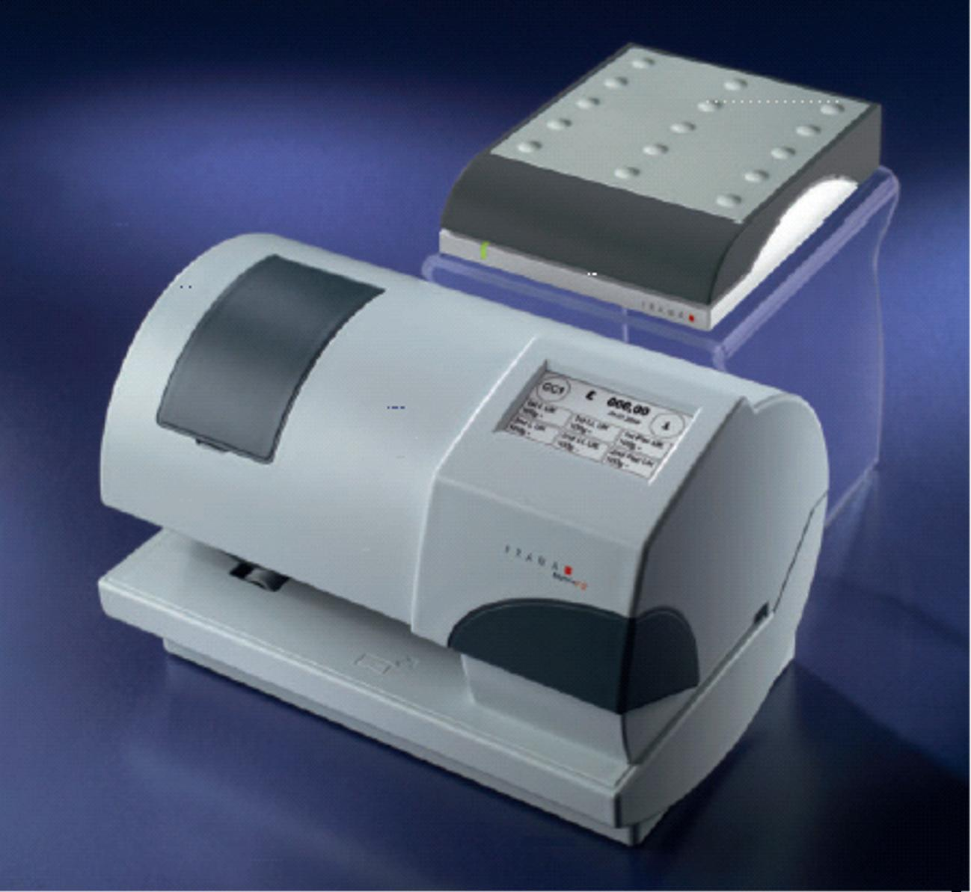

Further to page 99-1, here are illustrations of the new Frama Matrix machines:

The image on the right is the Matrix F2, which is a low-volume machine that can process up to 20 items per minute.

The image below is the mid-volume F4 / F6. The Matrix F4 can process up to 65 mail items per minute, whereas the Matrix F6 can process up to 100 items per minute.

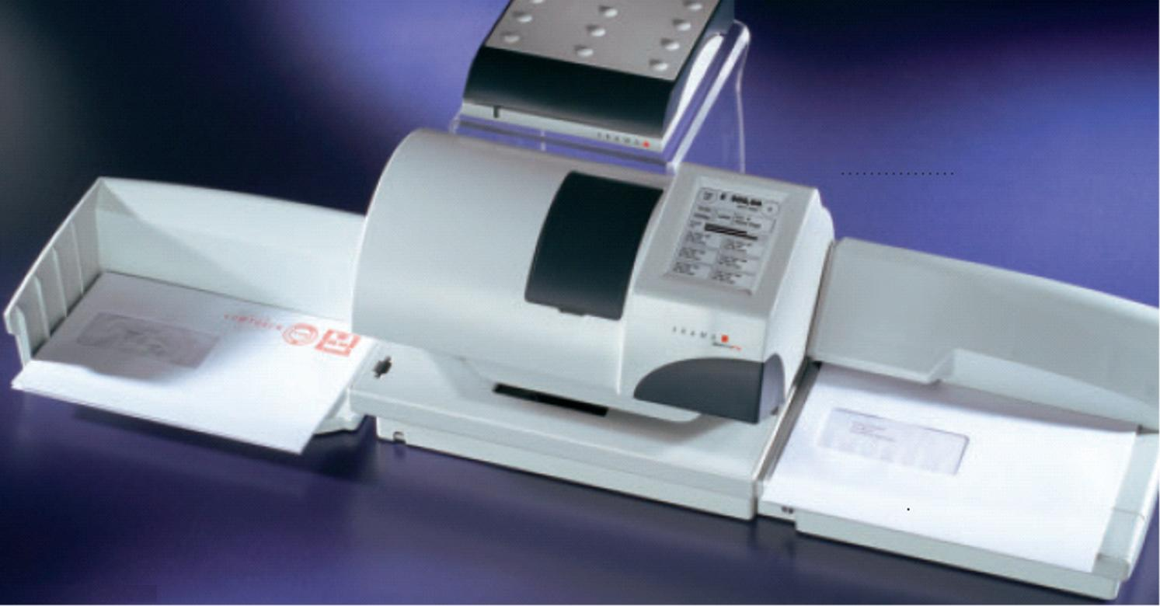

Further details can be found at http://www.frama.co.uk/Frama_UK___EN___Start.frm?ActiveID=2437

Meter Ephemera

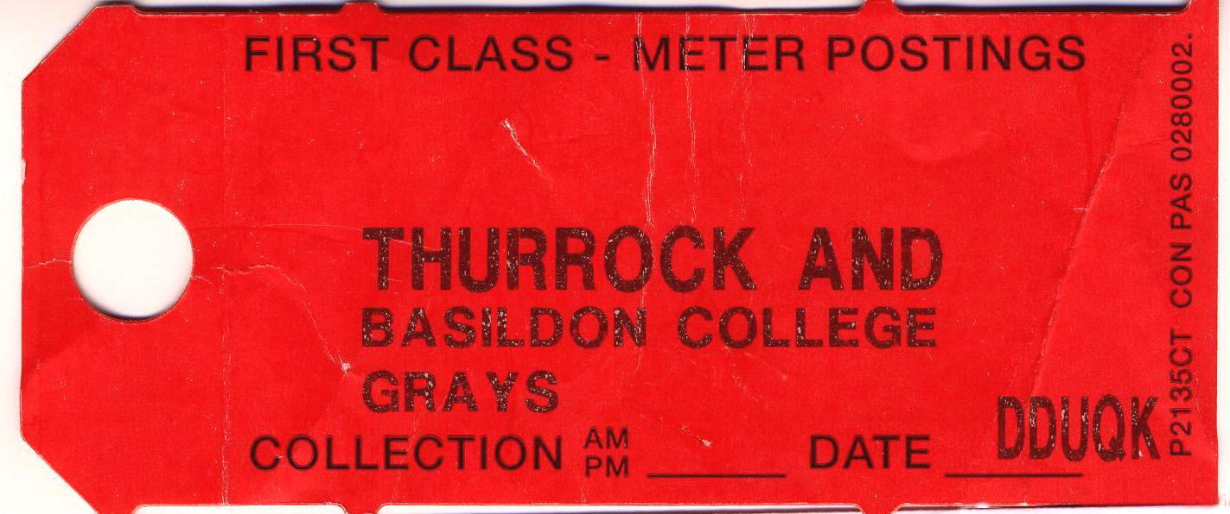
Richard Goring sends this bundle label from Thurrock and Basildon College. Such labels are normally inserted into the collection pouches of large users to identify the sender. They are rarely seen outside the Royal Mail sorting process and can greatly enhance a philatelic display.

Recent Interesting Items

Merv Dadswell sends this ‘SPECIAL DELIVERY’ mini-die (in conjunction with an Advanced Mail die) from a Francotyp-Postalia Centormail machine. I believe this is our first example of a mini-die from this machine, which the manufacturer calls a ‘Postage Endorsement’. The postage value applied by the user indicates, of course, that the item was not actually posted as a Royal Mail Special Delivery item.
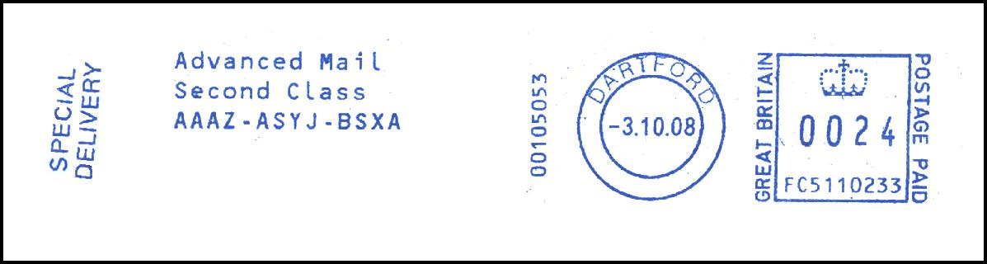

Peter Mantell sends this item with a text message ‘SPECIAL DELIVERY’. Your editor believes that this text has been entered manually by the user and is not a built-in slogan.


Peter Mantell has found our first examples of standard slogans on the Neopost N3 series. The first is an example of the familiar ‘GOOD MORNING’ slogan (see page 26-1):


The second is an ‘AIR MAIL / PAR AVION’ standard slogan:


Recent Interesting Items Continued

Further to pages 91-5, 94-3 and 96-3, Peter Mantell sends another town name in lower case font. Interestingly, all four examples seen so far have been on Neopost machines.
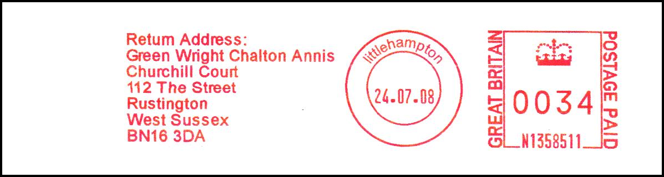

Richard Goring sends two scans of FM2117669 with item numbers 1 and 2 from the same day. It is assumed that the user has reset the item count on the day, and that these are not machine first impressions.




Further to pages 94-3 and 85-4, Richard Goring has found another Neopost frank with a lower case ‘wc1’ in the town die – this time on an IJ65 item.


Advanced Mail / Blue Ink Meters

Alan Godfrey sends two examples of blue ink use from the same user on two consecutive days. The first shows the dies used in conjunction with the ‘Advanced Mail’ facility and the second shows the standard slogan with an attractive eagle design.

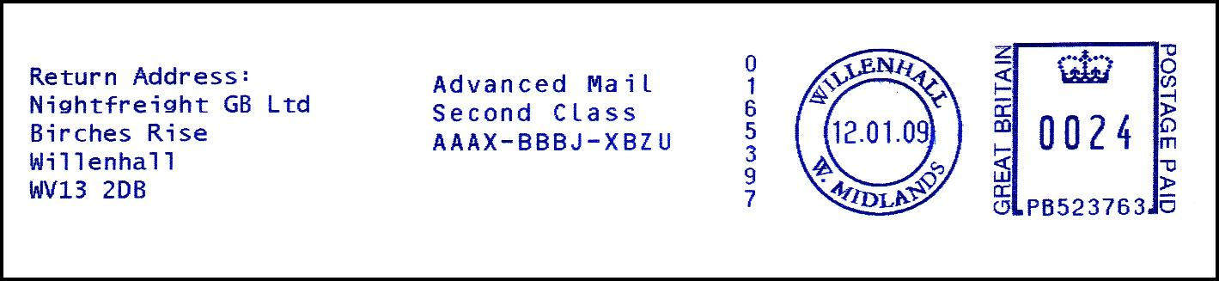



Richard Goring reports a new machine being used at Neopost’s Chesham office, but with a return address of Ingatestone. Note that on page 98-4, use of machine N1253525 at the Leeds office was reported. Are the serials N1253520 to N1253524 also being used by Neopost Ltd., I wonder?

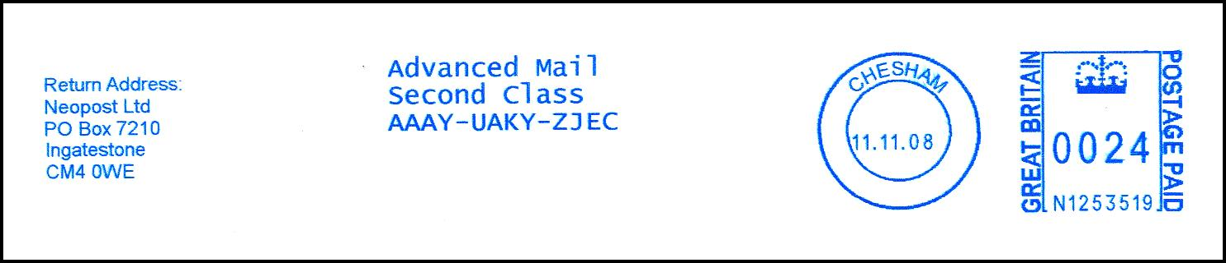

Further to page 85-5, Richard Goring reports an example of the same Francotyp-Postalia Jet Mail machine from the John Radcliffe hospital, but this time erroneously using red ink in conjunction with the Advanced Mail service:

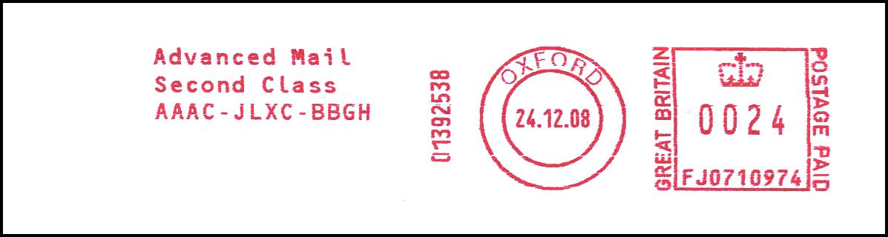

GPO Press Releases In the Run-up to Decimalisation (4)

Further to pages 96-5, 97-4 and 98-8, here is the last of the four GPO notices regarding the run-up to UK Decimalisation in February 1971, kindly supplied by Jim Ashby.

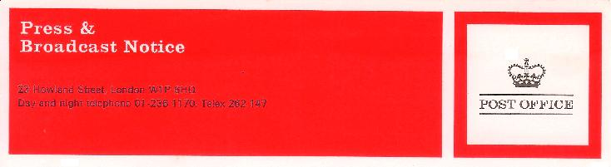

PB 288 November 13, 1970

CREDIBLE CREDITS FOR MAIL METERS

To ensure that all users of postal franking machines are correctly creited on Decimalisation Day, the Post Office is asking them for a special return of meter readings for the week ending February 13, 1971.

All franking machines issued since June 1968 by the five companies authorised to supply them have printed an all-pence postage value, as a simple figure without the pence sign. The companies have also been converting old-style machines. With the switch to decimal currency, the printed franking figures that now represent £sd values will be accepted as £p values.

This means that credit amounts still showing on meters will jump to nearly 2½ times their value over Decimal Weekend. To cover this sudden appreciation of value, the Post Office will use the special returns of meter readings to convert these amounts from £sd to £p, and charge the customer the difference.

On shillings-and-pence machines still in use on D-Day the Post Office will not renew credit once it is exhausted and machines that have not been converted to work all in pence cannot then be used to stamp mail.

NOTE TO EDITOR

Companies using franking meters pay for postage in advance. When the user visits the post office to make a payment, his next credit payment is added to the unused units still shown on the meter. Britain’s 85,000 franking machines are used to stamp about one-third of all letters and parcels posted in Britain.

Companies authorised to supply the machines are Pitney Bowes Ltd of Harlow, Roneo-Neopost of Richmond, Hasler (Great Britain) Ltd of Croydon, Friden Ltd of London SE1 and Acral Ltd, Bush Fair, Harlow.

Meter Thematics

Peter Mantell sends this slogan with the message “RNLI SOS 30 JAN 09”. The Royal National Lifeboats Institution, which is entirely funded by charity donations and manned by volunteers, held a nation-wide fund-raising event on 30 January 2009. Last year, the RNLI rescued 7533 people – an average of 21 people every day.
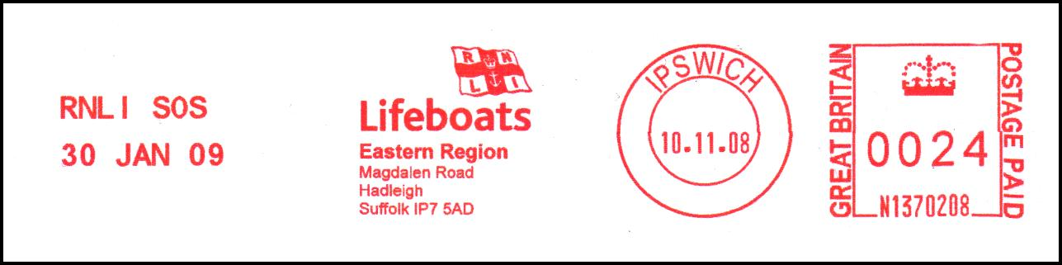

Your editor has also found this RNLI slogan from the South East Region headquarters at Uckfield, East Sussex:



Staying on the theme of flags, your editor has also found two more. The first one comes from a company called ‘QVSR’, which trades in African cultural wear. Note the lighthouse in the flag design.

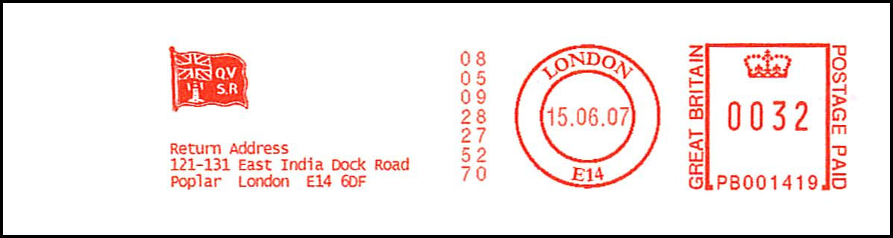

The second one, from Oceaneering International, Louisiana, shows the Stars and Stripes:
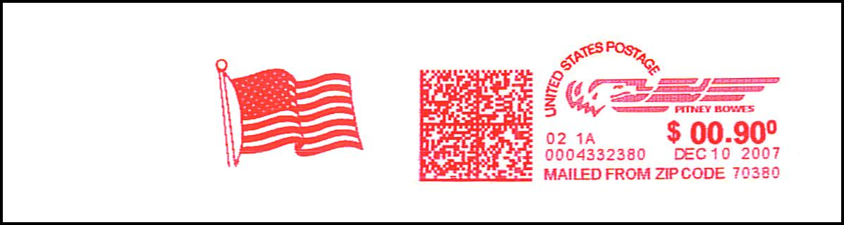

Meter Thematics Continued

Further to page 82-8, Peter Mantell adds to our collection of cathedrals with this one from St. Paul’s Cathedral.



Peter Mantell has found this attractive bird thematic design. Your editor believes it could be an arctic or little tern.
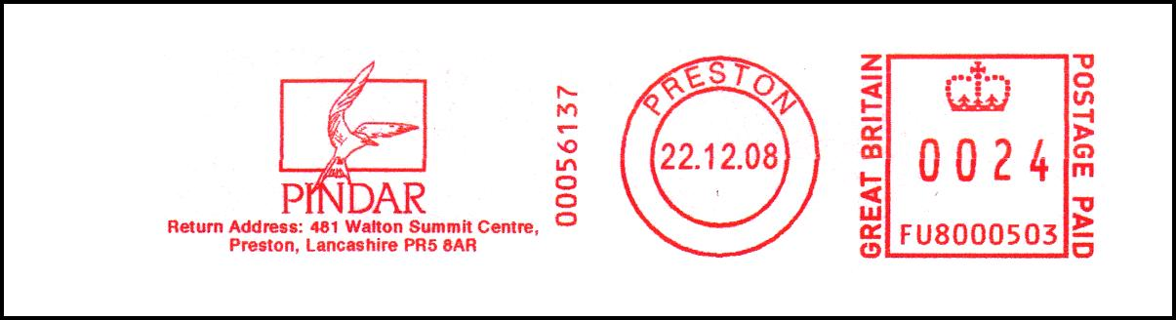

Meanwhile, Richard Goring has come across this rather cute Mallard duck in Warrington:

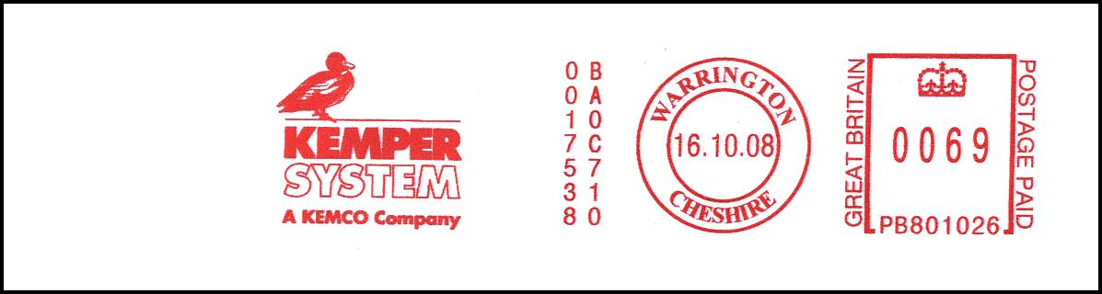

My meter thematic of the month is a rare 1966 item with a shipping and telecommunications theme that has recently been acquired by Peter Mantell. It is inscribed “FIRST TRANS-ATLANTIC RADIO AUCTION 16MAY on board R.M.S. Queen Mary…”

